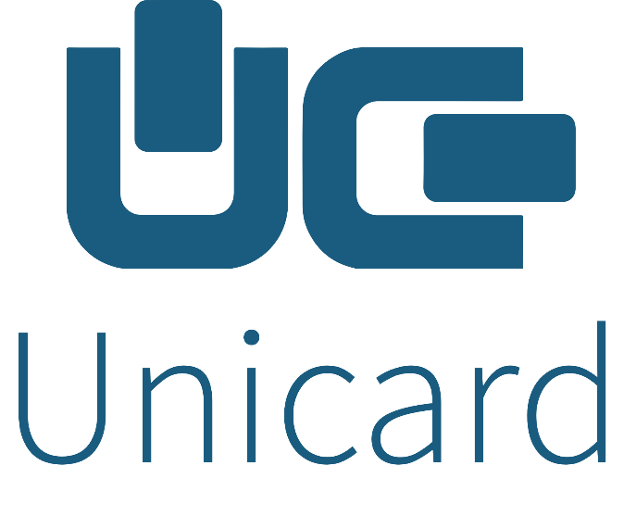

Project Manager Job Description

Date June 2021

INTERNAL ROLE TITLE: Project Manager | REPORTS TO: CEO
FUNCTION: Project Management | DEPARTMENT: CEO

Company Background
As the leading provider of software solutions for public and private sector transport management and smart ticketing, for nearly 20 years Unicard has been trusted by millions of passengers to get them where they need to be. Today, our solutions can be found throughout the UK, processing over half a billion transactions a year.
Since we started in 2003, a wide range of local authorities, transport operators and hardware manufacturers have depended on our capabilities in strategy, design, development, testing and delivery. We support a variety of customers, from simple single-user and concessionary travel programmes, to complex multi-modal and multi-operator configurations. Examples include:
- Our technology powers Transport for West Midlands’ trailblazing ‘Swift’ integrated ticketing system, one of the largest and most well-respected schemes in the UK, and the largest after “Oyster” in London
- We are trusted by 60+ local authorities to deliver their vital concessionary travel programmes – more than 40% of the market
- Over 30% of all ITSO card terminals in the UK run on Unicard software
- We have over 2.5 million cardholders currently under management, with transaction values in the tens of millions annually
Employing approximately 80+ people across the UK and Bulgaria, our in-house research, strategy and development capabilities give us an affordable, well-managed ability to develop market leading technologies and affordably maintain existing products. As a small-to-medium-sized enterprise, we pride ourselves on our reputation for outstanding products, technical support, delivery capability and high levels of customer service.

Role Purpose
Responsible for the day-to-day management and successful delivery of customer and internal projects, playing the lead role for project governance, planning, executing, monitoring, controlling and closing projects. The goal is to control and deliver projects using defined processes and controls, usually following the Prince2 methodology, to ensure they are managed and delivered within time, budget and to the highest possible quality.
Prince2 covers the controlling of project boundaries, stages, project delivery and a method to identify continuous improvements for both projects and the business. The ability to learn quickly and offer proactive insight and drive change, as well as bring new thinking and ways of working, split across different geographic locations, is a must, as is possessing drive, ambition and very strong interpersonal skills.

Essence of Role – Key Accountabilities
- Readiness to “roll your sleeves up” and “get stuck in”
- Project Plan creation and monitoring
- Good working knowledge and understanding of Software development process
- Ability to challenge constructively both internally and with the assigned customer(s)
- Collaborative worker
- Embrace Unicard values – we live by these
- Main point of contact for the customer during a project, establishing a good working relationship
- Continual Monitoring of Contracts to ensure scope of project is maintained
- Create / Update / Monitor & Manage various Project Documentation
- Project Brief / Project Verification document
- Knowledge and readiness to contribute to testing methodology
- Project Initiation Document (usually completed by customers rather than suppliers)
- Scope / Requirement Document
- Change Requests
- Work Packages
- Communication Management Document
- Risk Registers (RAID Log)
- Issue Registers
- Actions Logs
- System Overview
- Sign Off Documents for various Project Stages
- Configuration Records
- Exception Reports
- Highlight Reports
- Lessons Learned Log
- Project Risk Management
- Project Issue Management
- Provide regular Communication of Project Updates to Stakeholders internally and externally
- Monitor Scope and Requirements remain within the agreed deliverables
- Ensure Technical Requirements are clearly documented via an RfD (Request for Development) and managed
- Change Management Processes are followed and managed
- Manage creation of System Overview Document
- Product Delivery Management
- Order and Invoice Management for and during Project Delivery
- Identify Commercial Opportunities during Project
- Co-ordinate Project Resources and Planning
- Organise and review Test Scripts and agree Test Strategy
- Organise training
- Organise User Guides / Manuals
- Ensure Project Sign Offs are obtained to close various Project Stages
- Ensure Project Handover to Support is Completed Successfully
- Promote the company’s products/services which prove capable of addressing current or future clients’ needs and objectives
- Ensure that customer solutions are effectively delivered

Role Dimensions
Financial (limits/mandates etc.) | Non-financial (customers/staff etc)
- Managing delivery of Projects to budget and time  - Identifying customer requirement changes / improvements during Projects  - Promoting of Unicard Solutions and Services  - Managing Project Management Time / Costs Effectively  - Ensuring effective use of Project resource time, such as Software Development Staff to manage costs  - Maximising margin and/or profit in accordance with company objectives | - Management of customer relationships  - Create and Manage various Project Management documentation (see outputs)  - Follow all Unicard Governance and Procedures  - Ensure Project Governance is Managed  - Working closely with Internal Software Development, Test and Support Teams  - Hold regular Technical Workshops / Meetings  - Regular Communication with Customer, ensuring a strong relationship

Typical Outputs
- Successful delivery of Projects to customer business requirements
- Successful delivery of Project change requests as agreed between the customer and Unicard
- Remain within any Contractual requirements
- Project Documentation which includes;
  - Business Requirements
  - Project Brief / Verification
  - Communication Management Strategy
  - Project / Programme Plans
  - Project Issue Lists
  - Testing Issue Lists
  - Risk Registers
  - Technical Scopes
  - System Overview
  - Network Topology Diagrams
  - Hardware Asset Register
  - Change Requests
  - Quotations (where a change request deems one necessary)
  - Action Logs
  - Project gate / phase sign offs, to confirm customer satisfaction
  - Project > Support Handover
  - Lessons Learned Log
- Delivery of Software Development to the required scope
- Delivery of Hardware to the customers required specification
- Lead and participate in virtual project teams, to deliver end-to-end solutions to customer requirements
- Take overall responsibility to ensure Projects are delivered successfully
- Ensure long-term relationships are maintained with customers
- Develop the knowledge, skills and behaviours of self and others
- Delivery of Project orders and fully invoiced
- Develop new business opportunities during projects

Person Specification
Competency / Performance Driver | Technical / Professional Expertise
- Prince2 Practitioner Trained (or similar)  - Good communicator at all levels  - Approachable  - Pro-active approach  - Positively communicates with enthusiasm and clarity  - Determination to succeed  - Analytically minded  - Open mindedness  - Ability to translate business requirements into tangible solutions  - Listens and understands customers’ requirements  - Able to build successful customer – supplier relationships  - Delivers outstanding customer and project service  - Works collaboratively with others  - Manages risk  - Displays sound judgement, makes effective, timely decisions  - Dependable, takes personal responsibility  - Open, trustworthy and trusting  - Commercial awareness  - Self-disciplined and able to manage own time and resources  - Contractual and SLA Awareness  - Manages cost whilst maintaining profitability  - Seeks opportunities to learn and develop  - Able to advise and direct stakeholders  - Ability to influence and win respect | Essential:  - Prince2 Practitioner Accreditation (or similar)  - Demonstrate key project processes and documentation competency  - Fundamental Project Management Skills  - Project Life Cycle Management Experience  - Public Transport Smart Card / ITSO reading technology  - Managing implementation of Public Transport or Parking Software Development  - Demonstrate contractual and SLA awareness  - Experience of Network Infrastructures  - Experience of Data Migration Projects  - Understanding of Database Management  - Previous project experience of engaging and managing at all levels s  - Face to face customer engagement experience at all levels  - Commercial acumen and sound business understanding  - Demonstrable record of successful delivery of ticketing software and hardware  - Competent IT skills- Excel, Word and PowerPoint.  - Presentable and articulate  - A full UK driving license  Desirable:  - Experience delivering large scale complex projects  - Previous industry experience  - Knowledge of Unicard’s core products and services

What we offer
- Knowledge sharing (working with experienced professionals)
- Great work environment and friendly atmosphere
- Company cash plan
- Office with a central location or opportunity to work completely remote
- Additional health cover
- Auto-enrolment for pension
- Regular team-building and office events
- Career development
- Competitive remuneration package

